**Report on Zeroth Presentation of Project**

**SMART WHEELCHAIR AND HOME AUTOMATION FOR PARALYZED**

Submitted by

24. JASIRA T P

34. NAYANARAMESHAN

46. SHRAVAN SREEDEEP

48. SOORYA P

Guided by

Dr. C Sreekumar

**ABSTRACT**

Paralyzed stroke patients are unable to normally communicate with their environment. For these patients, the only part of their body that is under their control, in terms of muscular movement, is their eyeballs.

The biggest problem that paralyzed patients face is leading their own life without anyone else's help. This includes basic day to day operations like switching on basic devices like fan, bulb etc.

We are proposing an automated working prototype of a smart wheel chair and home automation system that can be controlled by eye tracking. The prototype shall be designed for paralysed people with only motor functions for eye movement. We are also considering on making aware of surrounding obstructions and make decisions accordingly.

**OBJECTIVES**

* To track eye movement and control basic devices like bulb, fan etc.
* To design and implement an autonomous electric wheelchair.
* To control the electric wheel chair by tracking eye movements.

**BLOCK DIAGRAM**

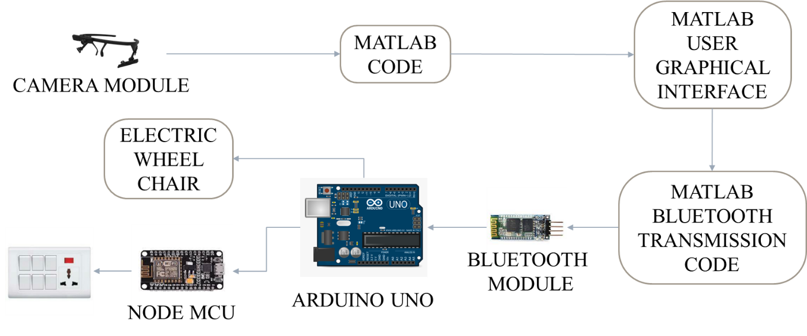

The camera module in eye tracker captures the eyeball movement. A pre trained model of eye tracker identifies the position of the pupil. The combination of position of the pupil is transmitted to the micro controller with the help of Bluetooth module. The micro controller determines the command that needed to be executed according to the position of pupil. Based on the command wheelchair or home appliances are selected. If the selected mode is wheel chair, then the movement is controlled based on the position of pupil. Else if home appliances are selected, the devices are turned ON based on the combinations of the pupil with the help of Node MCU and relay circuits.

**WORK PLAN**

**IMPROVEMENTS**

Possible problems:

1. The system needs a PC to track eye movement and pass commands all the time.
2. Detection of eye movement in dim areas.

Proposed Solutions:

We are considering on making the model run on a cloud platform or using Raspberry Pi micro controller instead of Arduino for better computing power.

The camera can be used to capture IR images after removing the IR filter in its lens. Then by using an IR led it is possible to image the eyeball even in dim lights.

**CONCLUSION**

The zeroth presentation on the topic “SMART WHEELCHAIR AND HOME AUTOMATION FOR PARALYZED” have been presented and the project was approved by the panel. A suggestion was provided by the panel to refer previous project report on similar topic.

**REFERENCE**

1. Ahmad F. Klaib1, Nawaf O. Alsrehin1, Wasen Y. Melhem2, Haneen O. Bashtawi2, Aws A. Magableh1. “Eye Tracking Algorithms, Techniques, Tools, and Applications with an Emphasis on Machine Learning and Internet of Things Technologies”, September 2020
2. Mohammed Saifuddin Munna1, Juliana Shetara, Shantanu Bhattacharjee3, Md. Zahed Hossain Bhuiyan4, “Design & Implementation of a Mind Controlled Home Automation System”, January 2017
3. Pramodini A. Punde, Dr. Mukti E. Jadhav, Dr. Ramesh R. Manza, “A study of Eye Tracking Technology and its applications”, 2017 IEEE
4. Tan Kian Hou, Yagasena and Chelladurai“Arduino based voice controlled wheelchair”, 2020
5. Mohammed Hayyan Al Sibai, Sulastri Abdhul Manap, “A Study on Smart Wheelchair Systems”, Dec 2015 Research Gate
6. Deepak Kumar, Reetu Malhotra, S R Sharma, “Design & Construction of a Smart Wheelchair”, 2019 Science Direct
7. Georges Boustany, Alaa El Deen Itani, Rayan Youssef, Omar Chami, Ziad O. Abu-Faraj, “Design and Development of Rehabilitive Eye-Tracking Based Home Automation System”, 2016 IEEE
8. Joseph K George, Subin K B, Arun Jose, Hima T, “Eye Controlled Home-Automation For Disables”, 2017 IOSR-JEEE
9. Deepak Kumar Lodhi, Prakshi Vats, Addala Varun1, Prashant Solanki, Ritakshi Gupta1, Manoj Kumar Pandey, Rajat Butola, “Smart Electronic Wheelchair Using Arduino and Bluetooth Module”, May 2016 IJCSMC